**Introduction to SAP SD**

**[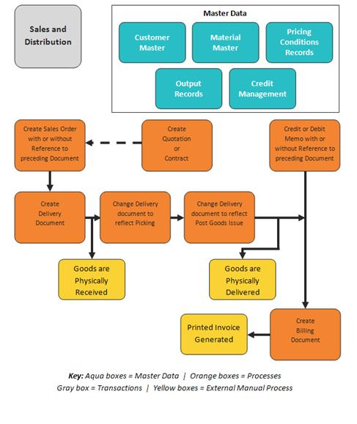](http://sap-erp.com/general/introduction-to-sap-sd.html)**[**INTRODUCTION TO SAP SD MODULE**](http://sap-erp.com/general/introduction-to-sap-sd.html)

Sales & Distribution (SD) is one of the core and most-used modules of SAP R/3 products beside Financial (FI), Controlling(CO), Material Management (MM), and Production Planning (PP) modules.

The Sales & Distribution (SD) module consists of various components also called sub-modules. Which are known as:

* (SD-BF) Basic Functions and Master Data in SD Processing. (Also subdivided in several components as: Pricing, Output…etc)
* (SD-BF-PR) Pricing and Conditions
* (SD-BF-EC) Extra Charge
* (SD-BF-CM) Availability Check and Requirements in Sales and Distribution Credit and Risk Management
* (SD-BF-AS) Material Sorting
* (SD-BF-OC) Output Determination
* (SD-SLS) Sales
* (SD-SLS-OA) Scheduling Agreements for Component Suppliers
* (SD-SLS-OA) Customer Service Processing
* (SD-FT) Foreign Trade/Customs
* (SD-BIL) Billing
* (SD-BIL-IV) Payment Card Processing
* (CAS) Sales Support: Computer-Aided Selling
* (SD-EDI) Electronic Data Interchange/IDoc Interface
* (LE-SHP) Shipping
* (LE-TRA) Transportation
* (SD-IS-REP) Reports and Analyses

The main areas covered by this module and the sub modules are:

* Pre-sales activities, including Inquiry and Quotation creation.
* Sales Order processing, including Sales Order (SO) creation.
* Shipping, including Outbound Delivery document creation.
* Billing, including Billing document and invoice creation.

Sales & Distribution (SD) is a module highly integrated with other SAP Modules as FI, CO, MM, PP & more. This can make SD a complex module, so as part of this Introduction we will also try to detail a normal sales process and how the activities integrate and are covered by this module.

* **Pre-sales activities:** It starts when a customer or a prospect requests information by any source about a product or service offered by the company. This request is processed through SAP and the the first integration we have is by the creation of a an Inquiry Document or a Quotation Document. At this point of the process we still haven’t effectively made a sale that’s why it is considered as a presale activity.

* **Sales Order processing:** Our quotation document previously created is send to our customer so they can make effective their purchase procedure. At this point they may want to negotiate payment terms, price, dates or any adjustments to the original document created by us.

As soon as we receive a Purchase Order (PO) from our Customer we create a Sales Order (SO) which makes reference to the previously created Quotation Document. Now scenario  is adjusted based on the business requirements. In some cases depending on the business Sales Orders (SO) can be made without a previously created quotation document as also in other scenario this can be a requirement.

* **Inventory Sourcing:** The product requirement from the Sales Order at the required date needs to be available by one of the following options:  
  To fulfill the products requirement from an SO at the required date, we can obtain them by one of these options:

o    Taking from Available stock at warehouse. At this point the SD module may trigger stock transfers between warehouses.

o    Triggering a production order to produce the products in-house.

o    Triggering a purchasing order to purchase the products from vendor.

Here is where the integration between Production Planning (PP) and Material Management (MM) starts.

* Shipping: When the product we sold is available at the warehouse, the sales personnel can start shipping activities by creating an outbound delivery document (Delivery Order/DO). Now this Deliver Order (DO) can be created by referring to our original Sales Order (SO). This will trigger the preparation of the product by the personnel of the warehouse. If the Warehouse Management (WM) module is integrated, a Deliver Order (DO) can trigger a Transfer Order. When the products are ready to be sent, the warehouse personnel will post the Goods Issue (GI) transaction that refers to the DO. The GI transaction will reduce the inventory level of products and then the warehouse personnel sends the products to the customer by transportation mode that has been determined in Sales Order (SO) document.
* Billing: This whole process will be managed before the delivery date specified in the Sales Order (SO) document. The finance department will generate a billing document and send an invoice form to the customer. The invoice will request the customer to pay the products we have sent at the price condition and terms of payment we have agreed in SO document.

**SD Main Functionalities**

